
IPSec Site to Site VPN
Cameron Schaff
Purpose:
The purpose of this lab is to gain insight into configuration of a site to site VPN Via a Fortigate Firewall system using IPsec’s suite of protocols for encryption and hashing between sites for encrypted and invisible connection to the outer world.
Background Information:
Fortigate 40F’s Design Philosophy
The Fortigate 40F series design philosophy was centered around creating an all-in-one appliance that would be suitable for securing networks across distributed enterprise sites. The Fortigate 40F operates on FortiOS, Fortinet’s proprietary operating system. Fortigate, along with FortiOS, incorporates AI-powered security services to automate end-to-end threat protection in real time. This application-specific design and embedded multi-core processor further enhances the convergence of networking and security functions within the 40F family, optimizing secure connections and delivering quick connections to the most remote locations.
IPsec
IPsec is a all-inclusive set of communication rules that establish secure communications over a network. It is based upon Internet Protocol (IP) and adds a layer of encryption and authentication to enhance the security of IP, as its name suggests. For instance, it encrypts data at the source and decrypts it at the destination, commonly referred to as encryption at the source and decryption at the destination.
IPSec protocols transmit data packets securely. Data packets are a specific structure that formats and prepares information for network transmission. They consist of a header, payload, and trailer.
Steps to encryption with IPsec
Establishing a Security Association (SA) is crucial for devices to agree on security parameters, including encryption and authentication methods. Protocols like Authentication Header (AH) and Encapsulating Security Payload (ESP) are used in IPsec. AH ensures data integrity and authentication, while ESP provides both integrity and encryption. IPsec encapsulates original IP packets, hiding the data and protecting it from unauthorized access. Key Management securely exchanges cryptographic keys for encryption and decryption, often using the Internet Key Exchange (IKE) protocol. Encrypted data is transmitted through the secure tunnel and decrypted at the destination using shared keys.

Virtual Private Networks (VPNs)
VPNs are networking software that enables users to browse the internet anonymously and securely. An IPSec VPN is a VPN software that utilizes the IPSec protocol to establish encrypted tunnels on the internet. It provides end-to-end encryption, ensuring that data is scrambled at the source and decrypted at the destination.

Lab Diagram
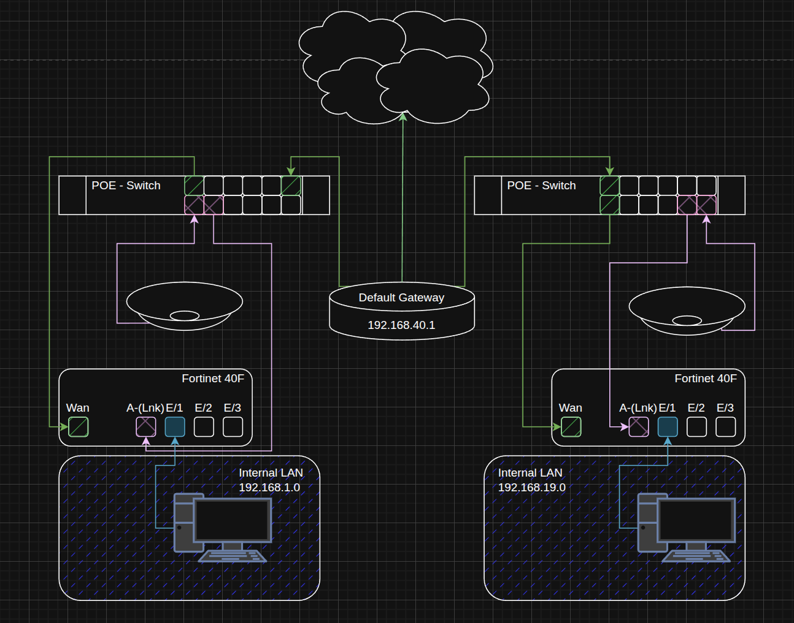
Lab Commands
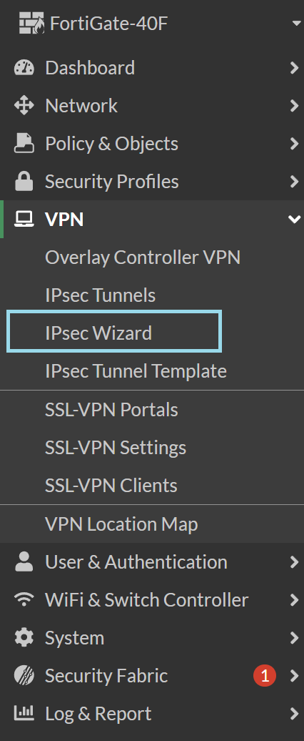
To start configurations it is essential to access the VPN wizard, a semi automated VPN creation tool provided by FortiGate.

Using a name for this VPN Tunnel will help later when identifying it. In this example I will use Fort 1to2. Then find and enter the other Firewall you are using for VPN configuration and enter its IP address
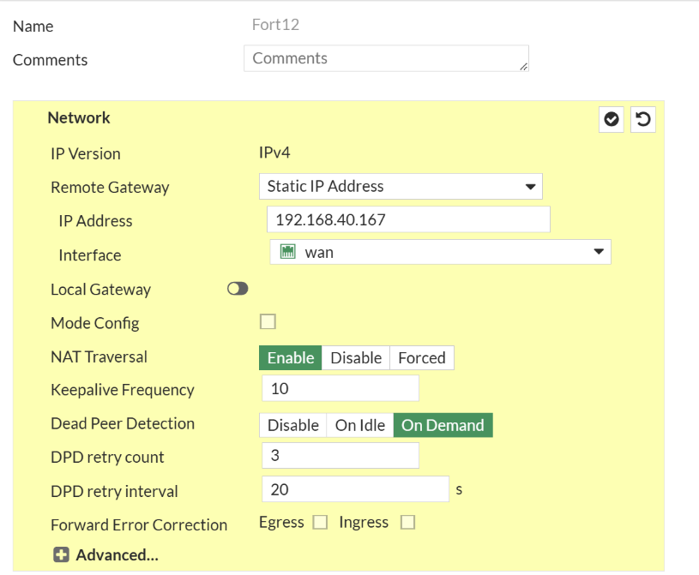
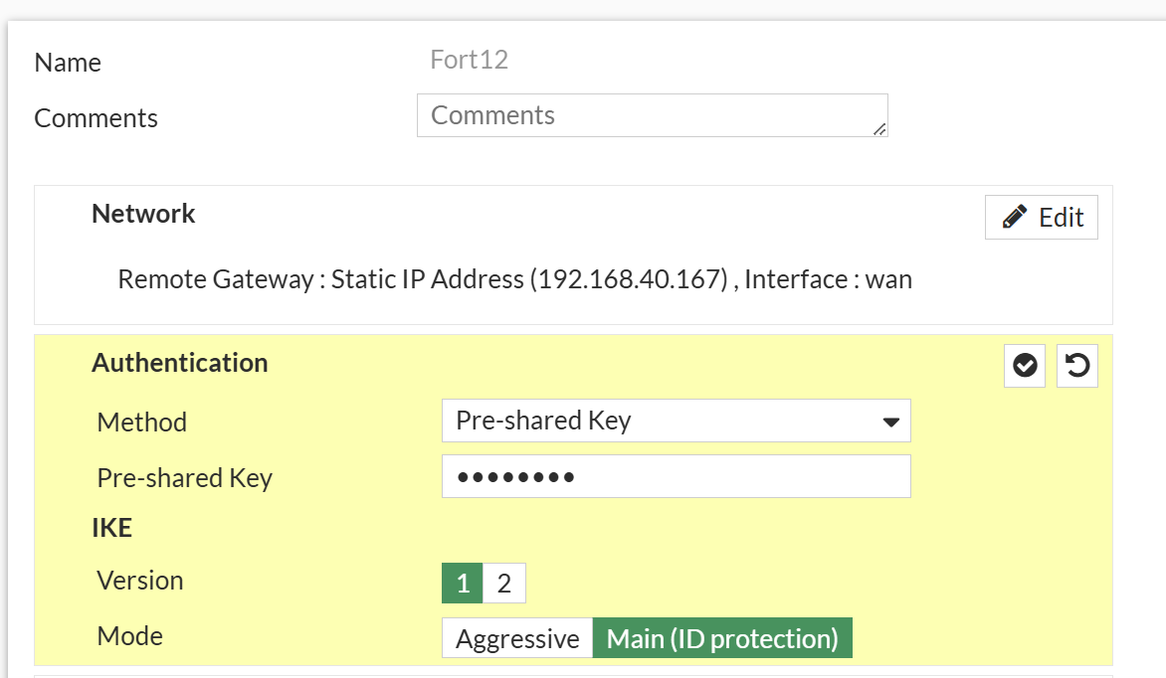
Enter the pre shared key into each firewall.
In the last section, configure the addresses with the Local being the firewall that is currently being configured and the remote being the other remote site’s firewall.
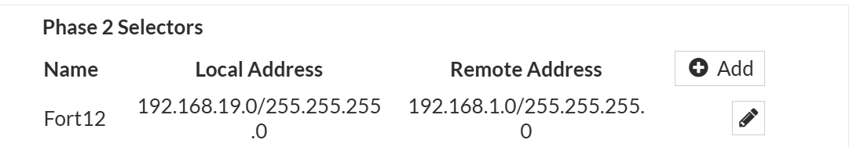

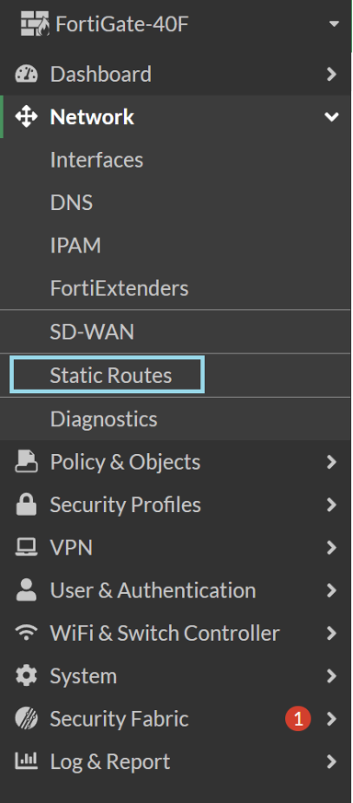
Navigate to Static Routes, the destination is the IP of your Linking Firewall

After entering the menu, click the “Create New” button located in the top right corner. Then, configure the interface as the new IPSec and the destination as the other firewall.

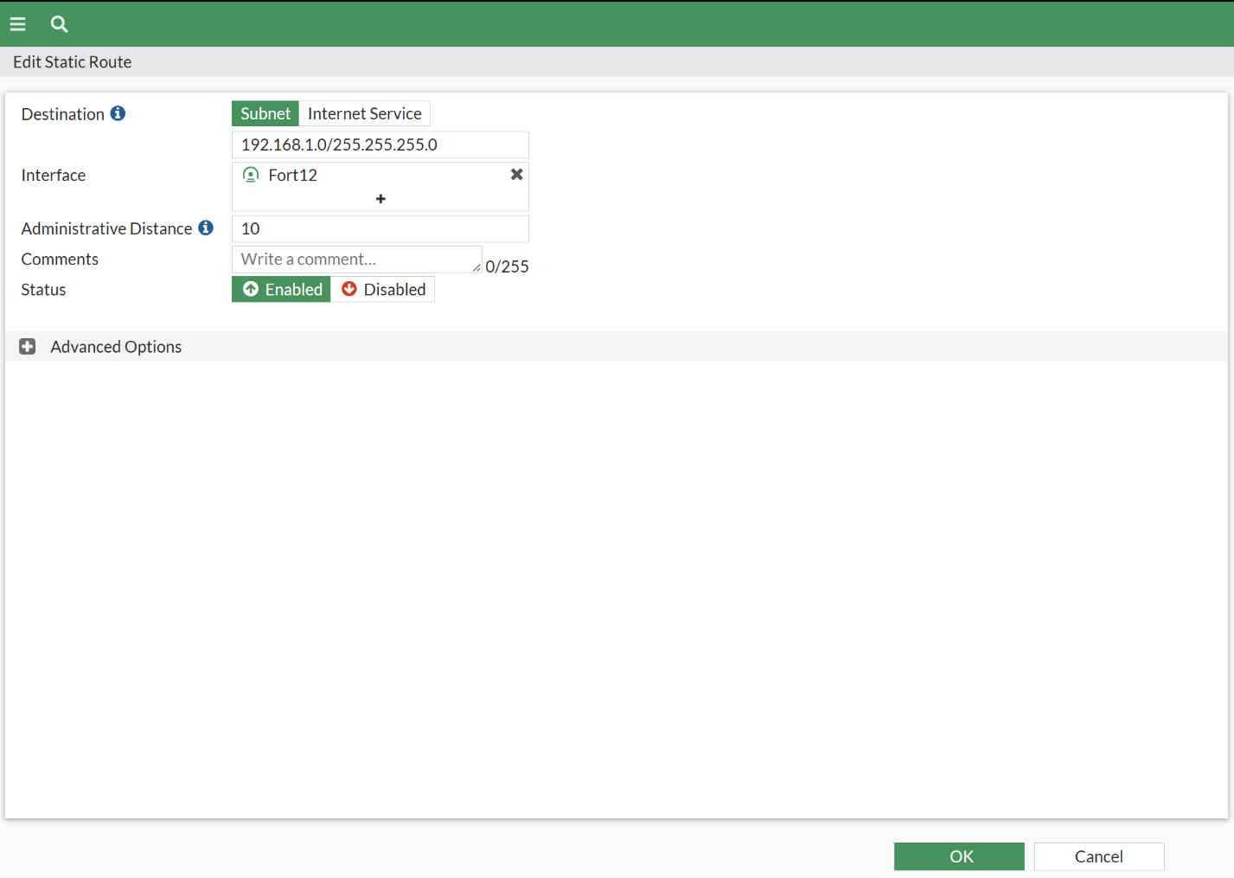

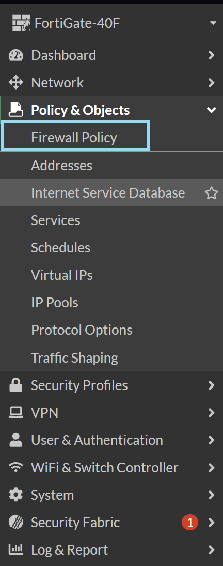
Now find the firewall policies in the sidebar and create a new policy.

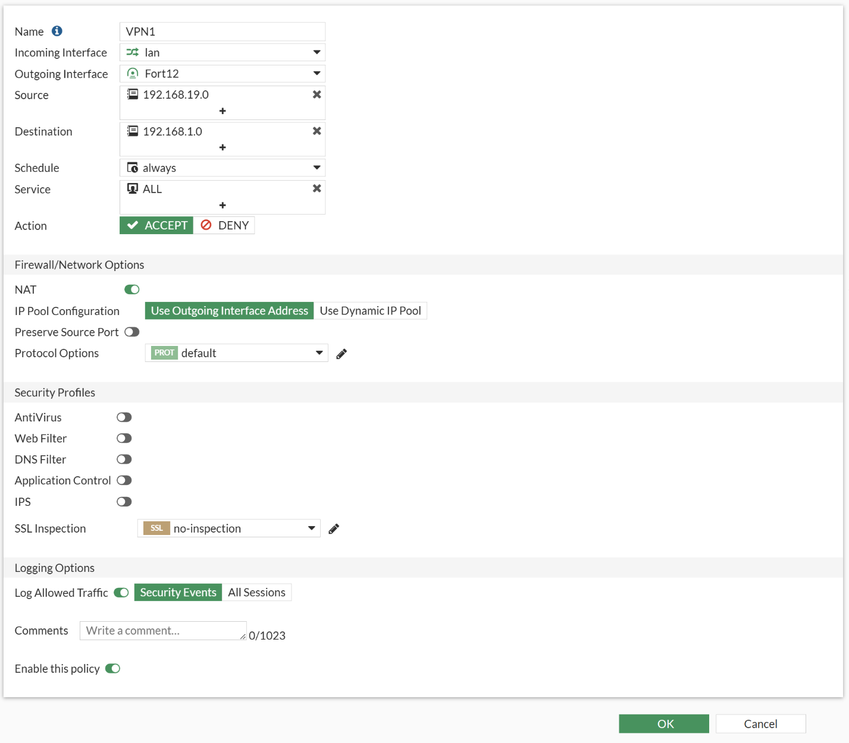
Create a new policy with these settings to allow for traffic to route in between.

Once configured some firewalls may have the option to right click -> clone reverse, however this firewall’s version does not. So create a new policy using these configurations.

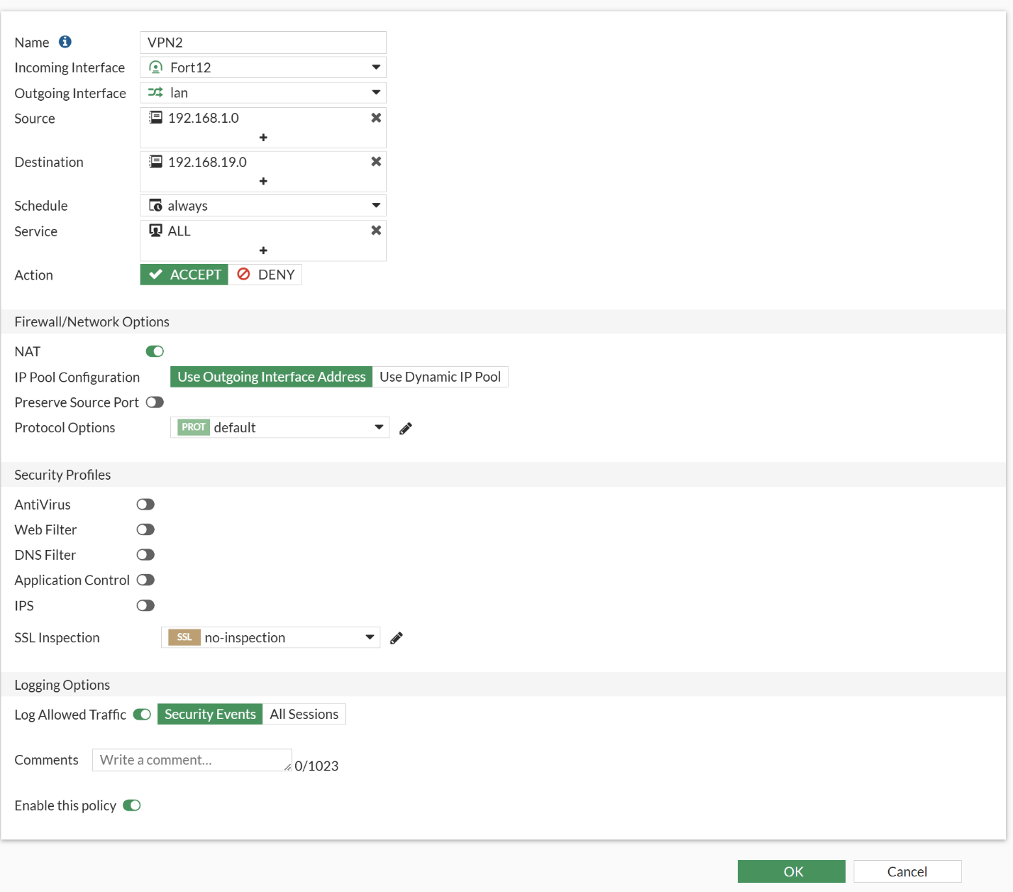
From this point on, make sure the other side’s firewalls are configured similarly with the addresses with Local and Remote being different.
Now navigate back to IPSec Tunnels.
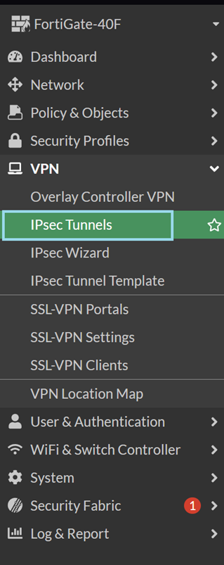
Click the red dot labeled [Inactive].
(In the example the color is green due to previous setup, however it lies in the same location and should look like this after configuration.)

Click on the status to bring up the selector menu o
right click and bring all Phase 2 layers up.
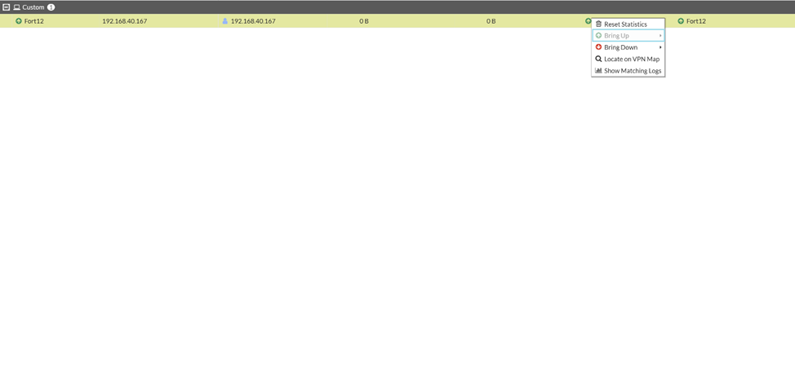
Issues
If either side has either the firewall policy misconfigured, or the IPsec tunnel addressed wrong the firewalls will not register each other as peers. To fix this make sure the addresses are correct on both ends of the firewalls and policies.
Conclusion
This lab demonstrates how to configure an IPsec site-to-site VPN. Through finishing the lab, a deeper understanding of how IPsec assists with data confidentiality, integrity, and authentication between two remote sites is gained.
This lab allows greater insight into the importance and intricacies of IPSec’s Site to Site technology and gives basic understanding into configuration of VPNS inside of FortiOS to see and understand configurations for security, integrity and authentication helping to better understand the connections between firewalls and other Fortinet devices.

Sign Off
